**CODE DOCUMENTATION**

**By Bhanu Pravallika Pothuru**

**Student ID: 001555471**

**Email ID: bpothuru@albany.edu**

**Follow the below given instructions to run the project:**

1. Connect to virtual machine and navigate to the directory where the project code resides
2. Run the server program using below command:

python server.py 10000 tcp

Server program takes port number and transport protocol to be used as the command line input.





1. In the local machine, Open the command prompt from the project folder
2. Run the cache program using the below command:

python cache.py 20001 icsi416-fa23.its.albany.edu 20000 tcp

Cache program takes port number, server IP, server port, and transport protocol to be used as the command line input





1. Run the client program using the below command:

python client.py icsi416-fa23.its.albany.edu 20000 localhost 20001 tcp

Client program takes server IP, server port, cache IP, cache port and the transport protocol to be used as a command line input.

1. Give commands to the client program to the initiate the data transfer





1. Quit command is used to quit the client program





1. Invalid commands are not accepted by the client program





1. Use put command followed by filename to upload a file to the server

Program accepts relative path from client_files folder, absolute path or filename

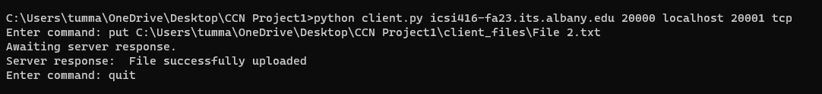

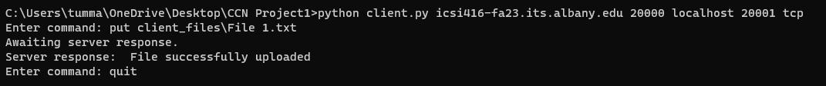

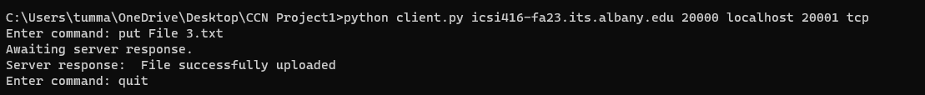





1. Program terminates on giving invalid filepath/filename with the put command

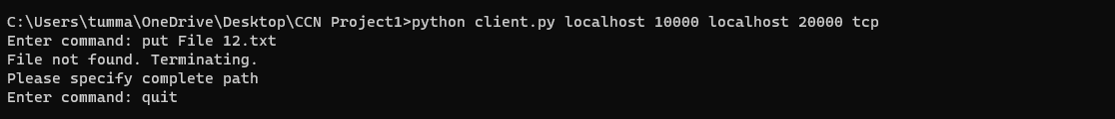

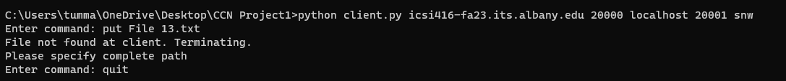

1. Get command followed by filename is used to download file from server/cache

When requested file is not present at the cache, the file is delivered from server





When requested file present at the cache, the file is delivered from cache.





When requested file is not present at server/cache, the program terminates





**Test cases:**

1. Put

TCP:

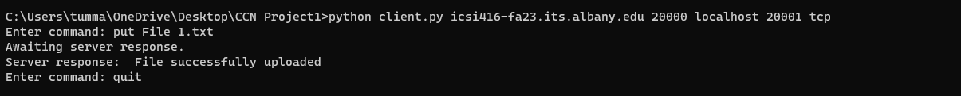

server_files folder: File uploaded to server



UDP:



server_files folder: File uploaded to server



1. Get from server

TCP:



client_files folder: File downloaded to client

cache_files folder: File downloaded to cache

UDP:



client_files folder: File downloaded to client

cache_files folder: File downloaded to cache

1. Get from cache:

TCP:



cache_files: File delivered from cache

client_files folder: File downloaded

UDP:



cache_files: File delivered from cache

client_files folder: File downloaded